- (10 pts) What makes Drosophila such an excellent model organism for the identification of genes involved in embryonic development? Describe the limitations of attempting to perform the same experiments in mouse embryos that Nusslein-Volhard et al. were able to circumvent with Drosophila.

- Historically, Drosophila was studied because its short life cycle (about 2 weeks), ease of culturing in the lab, and high rate of reproduction make it an excellent model organism. More recently, Drosophila remains an excellent model organism for the identification of genes involved in embryonic development because of its genetic tractability: Saturation mutagenetic screens can be performed relatively easily, and mutant phenotypes can be easily identified. Because Drosophila embryos are syncytial (the zygotic nuclei divide without undergoing cell division, so multiple nuclei are present within a single enclosed space), they do not require the expression of genes coding for the signaling pathways ordinarily required to coordinate developmental cues across cell membranes. The resulting decrease in complexity results, from a genetics perspective, in an organism that requires fewer developmental genes for proper embryonic development than, for example, mouse embryos.

- The challenges of comprehensively identifying the entire suite of genes required for proper mouse embryonic development are greater than those encountered in Drosophila due to a greater complexity of vertebrate embryological genetic interactions, a slower growth rate, and low rate of reproduction. The difficulty of maintaining the sheer number of individual animals required to perform a saturation screen for developmental genes precludes using a similar experimental approach in mice and other “higher” organisms. Nusslein-Volhard was able to circumvent these limitations because, as described above, Drosophila are easy to maintain, reproduce very rapidly, require less genes for embryonic development than mice. Finally, because Drosophila embryos form a unique pattern of denticle bands associated with each segment during development. It was possible for Nusslein-Volhard et al. to score defects in larval denticle band formation as a phenotypic correlate of axial patterning mutations. This type of easy phenotypic analysis is much more difficult when working with the mouse model.
  - It should be pointed out, however, that using mouse as a genetic model organism was made considerably easier very recently by Mario Capecci et al.
- (15 pts) Sketch and label a picture of the avian gastrula. Describe the pattern of cell migrations during avian gastrulation that give rise to the three germ layers. What do the first cells to migrate anteriorly give rise to? What cells/structure induces the neural plate?

Figure 1 showing the pattern of cell migrations during avian gastrulation that give rise to the three germ layers. 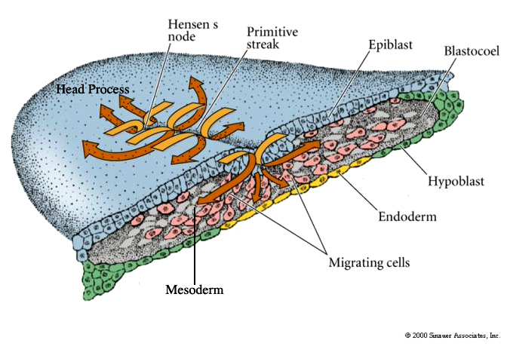

- The first cells to migrate anteriorly give rise to the primitive streak. The first cells to migrate through Hensens Node give turn anterior to give rise to fore gut endoderm and head mesoderm (Head Process) AND chordomesoderm.
- The cells migrating anterior and superficial (chordomesoderm) through Hensen’s node induce the neural plate.
- (15 pts) Scientists identified several “mutant” hydra in a stream contaminated by radioactive leakage from Chernobyl. First describe a “reaction diffusion” model to account for normal hydra body pattern (head, gastric zone, budding zone, foot) and then suggest an hypothesis to account for each new mutant phenotype.
Figure 1. Basic reaction-diffusion model morphogen production 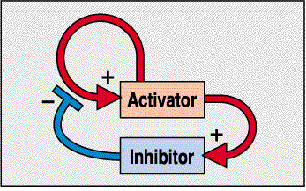
- Figures 1 through 3 describe the necessary requirements for a reaction diffusion model that accounts for normal hydra body pattern development.

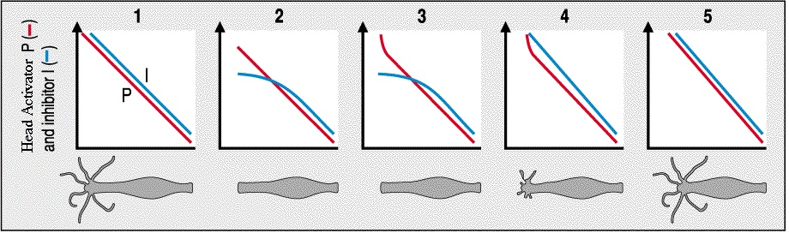
Figure 2. In an intact animal the head secretes a head activator (P) and head inhibitor (I). The concentration of the head inhibitor is greater than head activator all along the body axis. However, when the head is cut off, there is no source of either head activator or inhibitor. The inhibitor is more labile and degrades faster, so where the head activator concentration is greatest (nearest the head) is where it first becomes greater than the concentration of head inhibitor (graph 2). With the activator levels above the threshold for inhibition, a new head begins to develop and the concentration of head activator increases (graph 3). The new head produces not only head activator, but also inhibitor so the concentration of inhibitor soon rises above threshold for new head activation (graph 4). Thus one and only one head regenerates we are back to the steady state condition (graph 5)

3. (continued) (15 pts) Scientists identified several “mutant” hydra in a stream contaminated by radioactive leakage from Chernobyl. First describe a “reaction diffusion” model to account for normal hydra body pattern (head, gastric zone, budding zone, foot) and then suggest an hypothesis to account for each new mutant phenotype.
Figure 3. The foot is the source of a foot activator and a foot inhibitor morphogen gradients. The foot inhibitor diffuses faster and is more labile than the foot activator. The figure below graphs the levels of head inhibitor and foot inhibitor as the hydra grows. It illustrates that the budding zone is the body region where the hydra cells first escape from head inhibitor. Buds form "heads" first because they escape from head inhibition before foot inhibition. 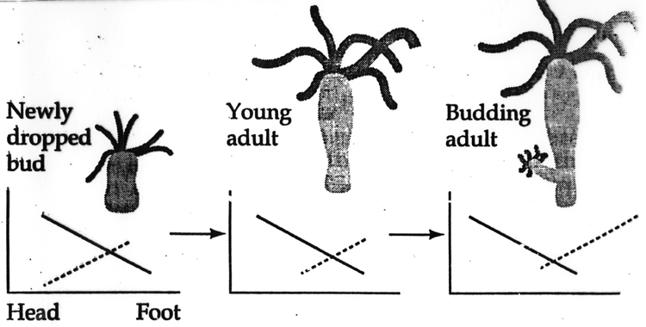

- There are many different scenarios that could give rise to either A, B, or C, and I'm sure I've missed a few. Therefore, all plausible explanations will be considered correct answers to the following questions.

A. Big head hydra. This hydra has a head that is three times larger than that seen in normal hydra. Rest of pattern looks normal.

- Here, a mutation could have occurred in the head activator gene promoter that causes it to be more autocatalytically sensitive to its own production would cause head activator protein to be overexpressed. Another option could be that a mutation in the head activator gene gives rise to a more stable head activator protein that diffuses at the same wild-type rate but persists longer in an active state. Finally, a mutation that results in a faster-diffusing head activator with wild-type stability could also cause this.

3. (continued) (15 pts) Scientists identified several “mutant” hydra in a stream contaminated by radioactive leakage from Chernobyl. First describe a “reaction diffusion” model to account for normal hydra body pattern (head, gastric zone, budding zone, foot) and then suggest an hypothesis to account for each new mutant phenotype.

- There are many different scenarios that could give rise to either A, B, or C, and I'm sure I've missed a few. Therefore, all plausible explanations will be considered correct answers to the following questions.

B. Stubby budding hydra. This hydra never grows as large/long as a normal hydra.

- A mutation in the head activator that makes it diffuse even slower could account for the stubby budding phenotype. Also, a mutation that makes the head activator less stable could allow the foot zone to expand, resulting in less distance between head and foot regions. Mutations involving the foot activator/inhibitor could also cause this phenotype. For example, mutations that cause foot activator to diffuse more quickly or degrade more slowly than wild type could result in premature foot development, again resulting in a shorter hydra body. Conversely, mutations that result in slower foot inhibitor diffusion and or faster degradation would have a similar effect.

C. Foot budder hydra. This hydra looks pretty normal, reproduces by budding foot first instead of head first from the budding zone.

- Buds form "heads" first because they escape from head inhibition before foot inhibition, so mutations that increase head inhibition and decrease foot inhibition would result in this phenotype.
4. What class of gene is Krupple? What is the phenotype of a Krupple mutant? Draw out a fly embryo showing Krupple protein expression and describe how this pattern of expression is regulated. I suggest you sketch out the important morphogen gradients below the embryo and propose regulatory interactions that could account for the Krupple protein pattern.

- Krupple is a Drosophila GAP gene that is expressed in the middle region of the developing embryo fated to give rise to the anterior segments (Figure 1).
- Krupple mutant flies are missing these anterior segments (Figure 1).
Figure 1. 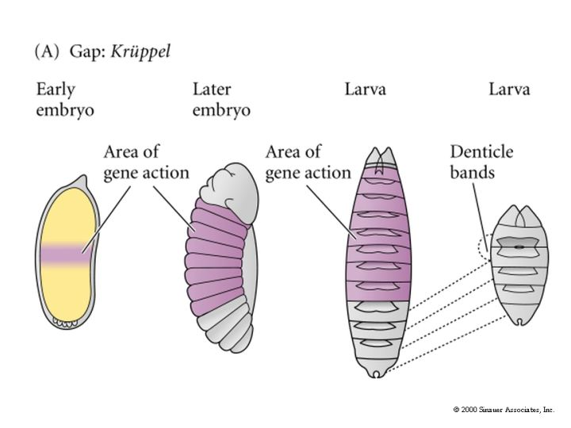
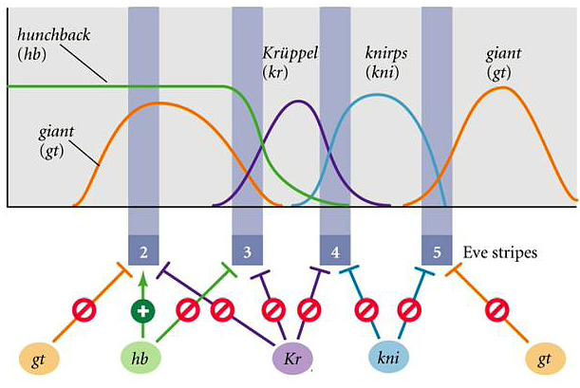Figure 2. Regulatory interactions that account for the Krupple protein pattern

5. Bob Horvitz received the Nobel Prize in 2002. What important developmental process did he discover? Describe his evidence in support of this fundamental cellular process. Why did it have implications beyond development?

- Bob Horvitz noted that there were actually 1090 somatic cells in the adult worm, but 131 of these cells underwent programmed cell death. He then performed screens to identify mutants where some of these cells that were programmed to die actually lived; and, in contrast where specific cells that normally lived underwent apoptosis. Up until the late 1980’s apoptosis was a theory not readily accepted by all scientists.
  - Dr. Horvitz's research had implications beyond development because defective apoptotic processes have been implicated in an extensive variety of diseases.
  - Excessive apoptosis causes atrophy, such as in ischemic damage, whereas an insufficient amount results in uncontrolled cell proliferation, such as cancer.
6. (10 pts) What is meant by an organ "identity" gene? Give the evidence for this concept and describe an example.

- An organ identity gene describes a gene that is both necessary and sufficient for the development of a particular organ. Organ identity genes are expressed throughout the particular organs that they give rise to. Importantly, ectopic expression of organ identity genes results in ectopic development of their gene-specific organs.
  - The pha-4 gene, which gives rise to the pharynx, is an organ identity gene. pha-4 is a member of the FoxA subclass.
  - Another example of an organ identity gene is the pax-6/eyeless gene, which is required for eye development in both flies and vertebrates. The loss of the pax-6/eyeless gene will cause the loss of eyes in both the fly and vertebrates. Ectopic expression of eyeless in the fly will induce ectopic eyes.
7. (15 pts) Wnt-7A primarily regulates what patterning axis in limb development? What is the limb phenotype of the mouse Wnt-7A knockout? Explain HOW missing Wnt-7A affects patterning of more than just one limb axis.

- Wnt-7a is expressed by dorsal ectoderm. It induces Lmx-1 in the dorsal mesoderm and specifies dorsal pattern.
- The Wnt7a KO mouse has a ventralized limb that is also missing posterior pattern elements and truncated. The affects on AP and PD patterning are thought to be due to Wnt7a normal function as a positive regulator of Shh (Figure 1 A). Reduced Shh would lead to AP patterning defects and also PD defects because of Shh importance as a positive regulator of Fgf (Figure 1 B). The en-1 KO mouse has a dorsalized limb and the AER forms at a more ventral location.
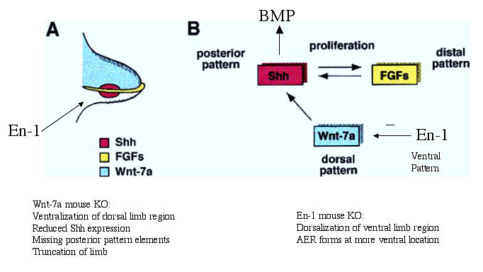Figure 1.

8. (10 pts) ALS or Lou Gehrig's disease results in the death of motor neurons. We isolate fibroblasts from a patient with ALS, make iPS cells and repair the genetic defect. Now we need to make a large number of motor neurons for transplantation back into the patient. What will surely be one important "component" we will use in our protocol to make motor neurons? Explain why.

- The specification of motor neuron progenitor cells is strictly dependent on a particular amount of sonic hedgehog (SHH) that is secreted from the notochord during human embryonic development (Figure 1 A & B). Human motor neuron development also requires expression of specific Hox genes, many of which are retinoic acid (RA) response elements. Therefore, an important "component" of our protocol will include application of the correct amount of SHH in the presence of RA in order to specifically drive human motor neuronal differentiation for transplantation back into the body. Interestingly, this procedure is actually being used in laboratories and has proven very successful! Figure 1 C shows how threshold values of Shh could differentially specify the identity of neurons in the ventral region of the neural axis in the presence of RA.

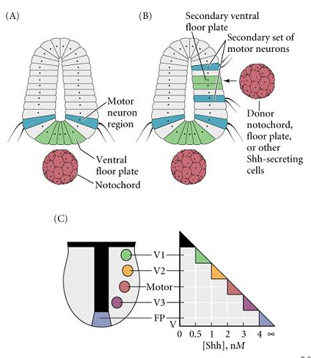
+ RA
9. (10 pts) Extra credit. "It's a beautiful accident of evolution," says Philip A. Beachy, a Howard Hughes Medical Institute investigator at Johns Hopkins University and one of the key players in this genetic detective story. In early tests researchers have stopped the growth of the most virulent human tumors, varieties accounting for 25% of cancer deaths.
What is he referring to as "a beautiful accident of evolution?" Tell me the story of the curious sheep and its importance to development and cancer research.

Idaho sheep ranchers couldn't figure out why, in the decade after World War II, a random batch of their lambs were being born with strange birth defects. The creatures had underdeveloped brains and a single eye planted, Cyclops-like, in the middle of their foreheads. In 1957 they called in scientists from the U.S. Department of Agriculture to investigate. The scientists worked for 11 years to solve the mystery. One of them, Lynn James, lived with the sheep for three summers before discovering the culprit: corn lilies. When the animals moved to higher ground during droughts, they snacked on the flowers. The lilies, it turned out, contained a poison, later dubbed cyclopamine, that stunted developing lamb embryos. The mothers remained unharmed. The case of the cyclopamine and the one-eyed Idaho lambs remained a freakish chemistry footnote for the next 25 years; researchers never could uncover why cyclopamine caused birth defects.
But now cancer researchers have improbably seized on the obscure plant chemical as the blueprint for a half-dozen promising tumor-fighters. Cyclopamine, it turns out, blocks the function of a gene called Sonic hedgehog that is essential for embryonic development but also plays a lead role in causing deadly cancers of the pancreas, skin, prostate and esophagus. "It's a beautiful accident of evolution," says Philip A. Beachy, a Howard Hughes Medical Institute investigator at Johns Hopkins University and one of the key players in this genetic detective story. In early tests researchers have stopped the growth of the most virulent human tumors, varieties accounting for 25% of cancer deaths.
Matthew Scott of Stanford and a team at UC, San Francisco, working separately, made a huge connection: Defects in hedgehog or related genes were present in two rare diseases linked to cancers. One, called Gorlin's syndrome, sometimes causes basal cell skin cancer to blanket patients as soon as they hit puberty. A second, called medulloblastoma, afflicts the brains of nearly 400 children a year in the U.S., often fatally. Normally the hedgehog gene is dormant in adults. But Beachy theorized it is needed to make repairs in parts of the body that undergo constant regeneration, as in chronic acid reflux, where Sonic hedgehog works overtime to reline the throat. When the gene's activity goes awry in places like the lungs and skin, it can lead to tumors. Beachy has turned normal prostate cells cancerous with a single mutation in Sonic hedgehog.

